**Create an Advertisement in Facebook**

**Brand Name**

**AZHARA SWEETS**

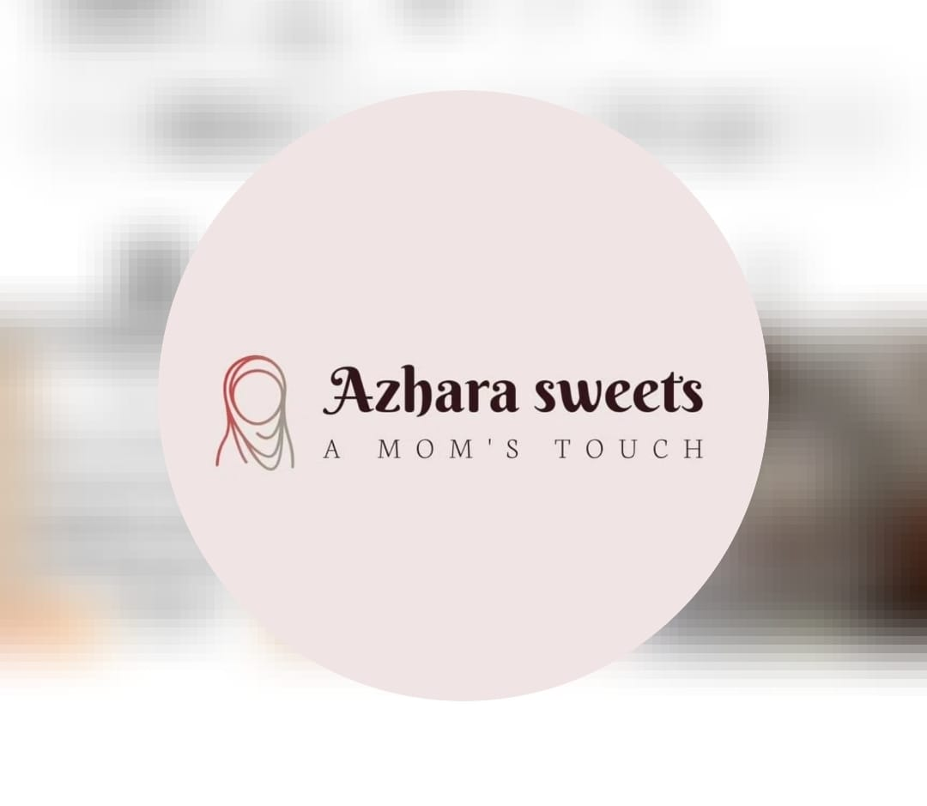

**OUR TEAM MEMBERS**

**MOHAMED V D N (TL)**

**RAHUL S**

**NIJANTHAN V**

**KANIMOZHI P L**

We are from University College of Engineering BIT Campus, Trichy pursuing our Final year in ECE

**Abstract:**

Sweets shops, often referred to as confectioneries or candy stores, are delightful establishments that offer a wide array of delectable treats to satisfy our sweet cravings. This abstract provides an overview of the enchanting world of sweets shops, encompassing their historical significance, diverse product offerings, and the evolving consumer preferences that have shaped this industry.

The history of sweets shops dates back centuries, with confectionery traditions rooted in various cultures around the world. From ancient civilizations to modern societies, sweets have played a significant role in cultural celebrations, rituals, and daily life. This historical context sets the stage for understanding the enduring appeal of sweets shops.

Sweets shops today are a haven for those with a sweet tooth. They offer a vast assortment of candies, chocolates, pastries, and other sweet delights. The variety of products available caters to a wide range of tastes, from traditional to innovative. These establishments often prioritize quality, flavor, and presentation, ensuring that every indulgence is a memorable experience.

As consumer preferences continue to evolve, sweets shops have adapted to meet changing demands. This adaptation includes the introduction of healthier options, organic ingredients, and dietary-conscious offerings to accommodate a diverse customer base. Moreover, the aesthetics and ambiance of these shops have become integral to the overall experience, with many establishments investing in visually appealing displays and cozy interiors.

In conclusion, sweets shops are more than mere purveyors of sugary delights; they are cultural touchstones and culinary destinations that continue to enchant and evolve. This abstract provides a glimpse into the world of sweets shops, shedding light on their historical significance, diverse product offerings, and their ability to adapt to the ever-changing landscape of consumer preferences.

**Introduction:**

Creating a mock sponsored post for Facebook in digital marketing involves crafting a compelling advertisement that appears in users' Facebook feeds, aimed at promoting a product, service, event, or brand. The objective is to engage the audience, generate leads, and drive conversions.

**TOPIC:**

**Brand Name:** AZHARA SWEETS

**Category:** Sweets & Bakery

**Target Audience:** Mens, Womens and Kids

**Email :** azharasweets@gmail.com

**Facebook Business page:** [**https://www.facebook.com/azharasweets/**](https://www.facebook.com/azharasweets/)

Screenshots:

**Step 1:** Open a Facebook page

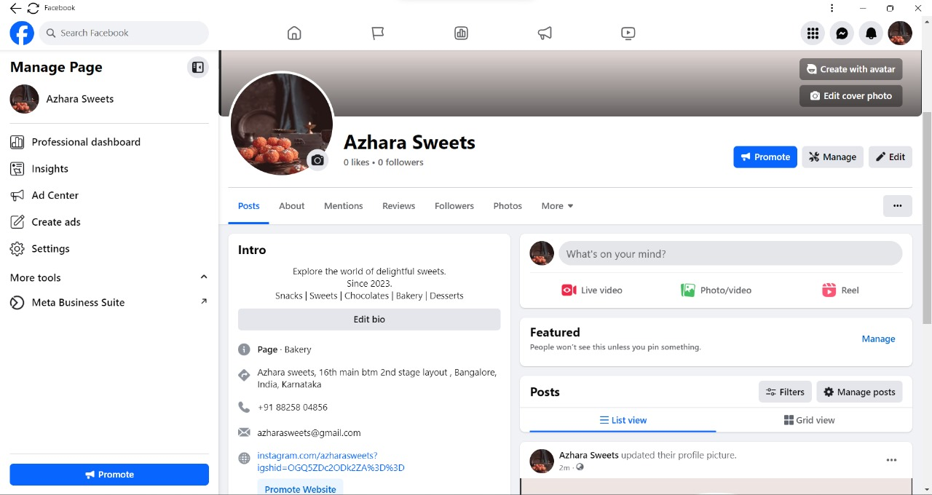

**Step 2:** Click a Menu then open a menu bar

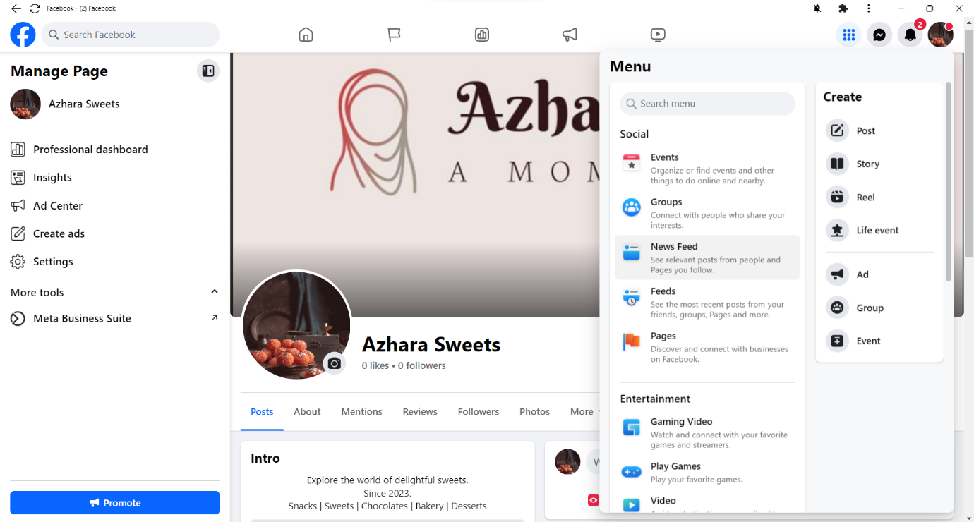

**Step 3:** Click the ad option of the menu bar then display ad type

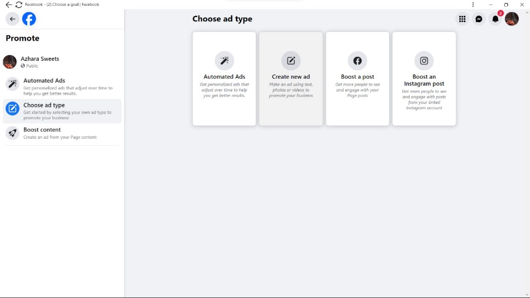

**Step 4:** After clicking a Create new ad then New Window will pop up

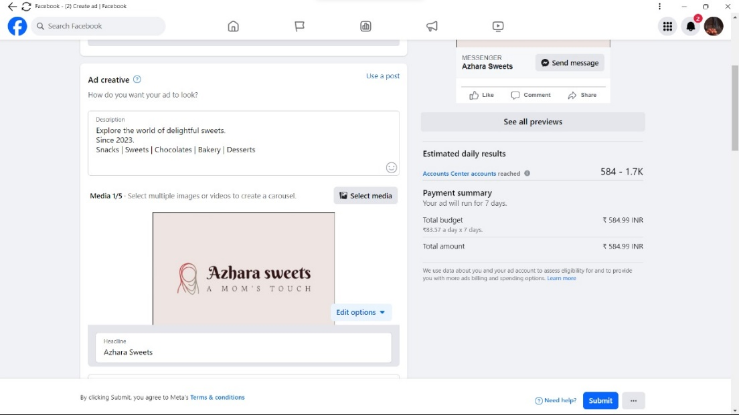

**Step 5:** Click on Select Media and then select the post you want to use for ad

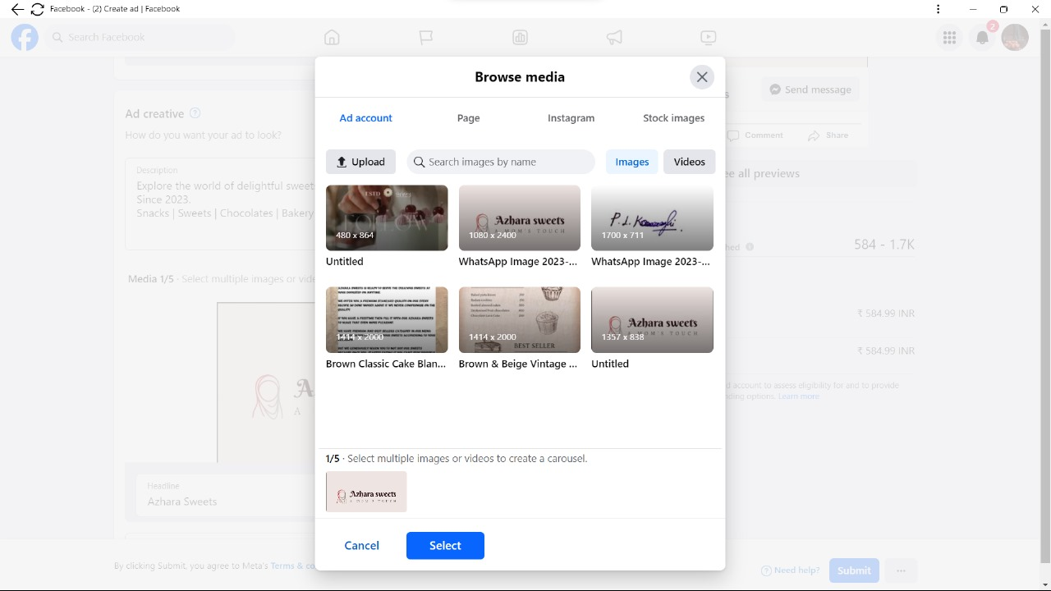

**Step 6:** After selecting the post click on select button and then a new window will pop up

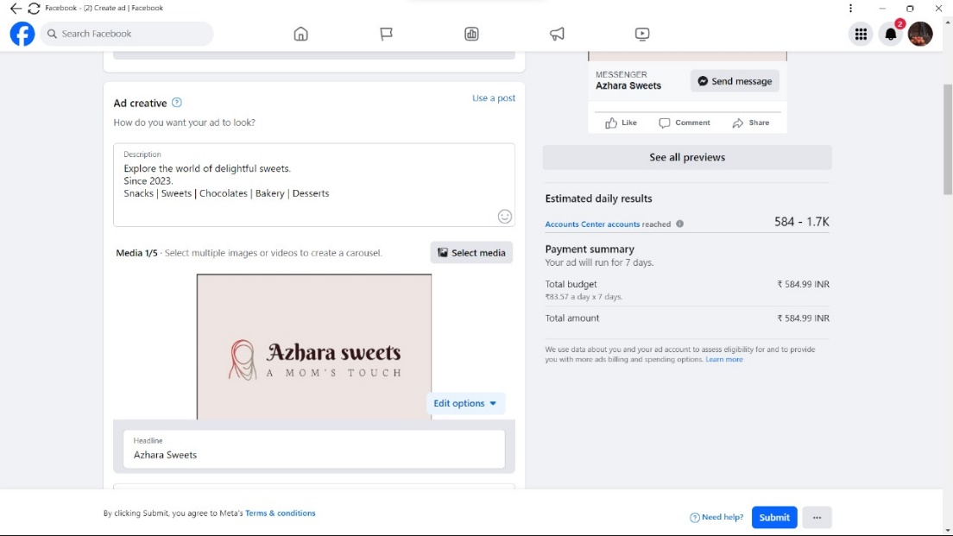

**Step 7:** click on the “button label” dropdown box

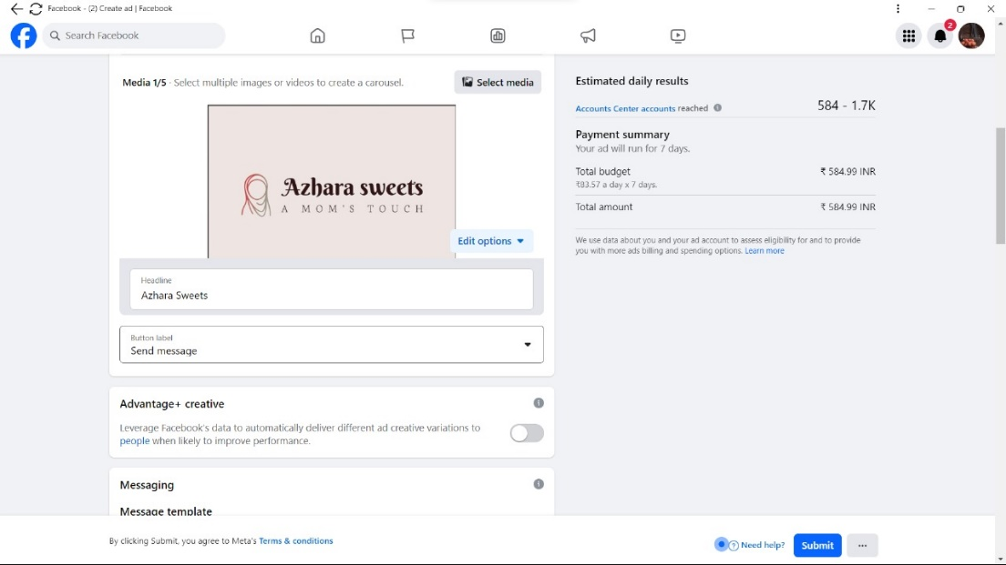

**Step 8:** After click “button label” dropdown box then select “Shop Now” option

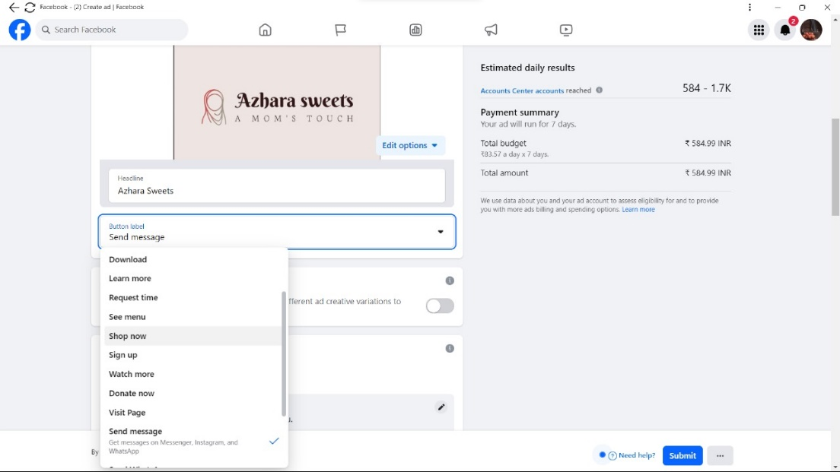

**Step 9:** Select your plan

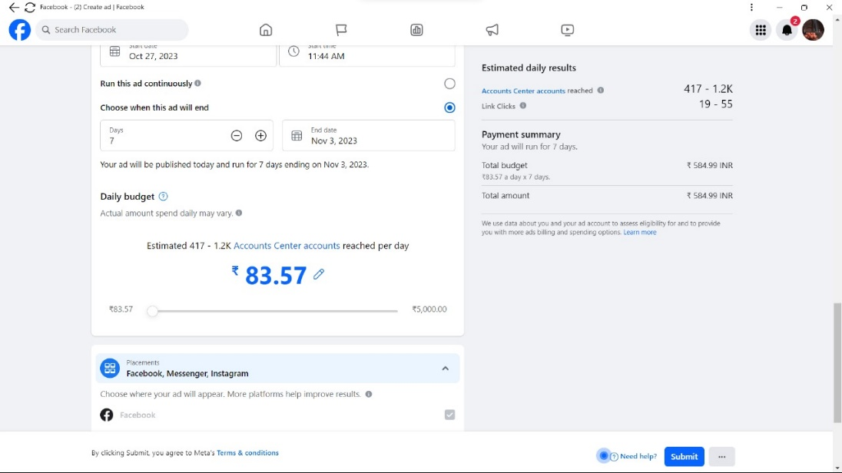

**Step 10:** After Select your plan then click on publish button

After click publish button Select your payment option and then pay money



**Final Preview**

